🚚 AWS Migration — Interview Explanation (Clean + Practical)

🧠 1. What is AWS Migration?
👉 Simple definition (say this first in interview):
“Migration is the process of moving applications or data from on-premises or one environment to AWS, or even between AWS regions.”

📦 Examples
- On-prem server → Amazon EC2
- Database → Amazon RDS
- Mumbai region → US-East region

🔥 2. Types of Migration (VERY IMPORTANT)
👉 This is a must-answer question

🔹 1. Rehost (Lift & Shift)
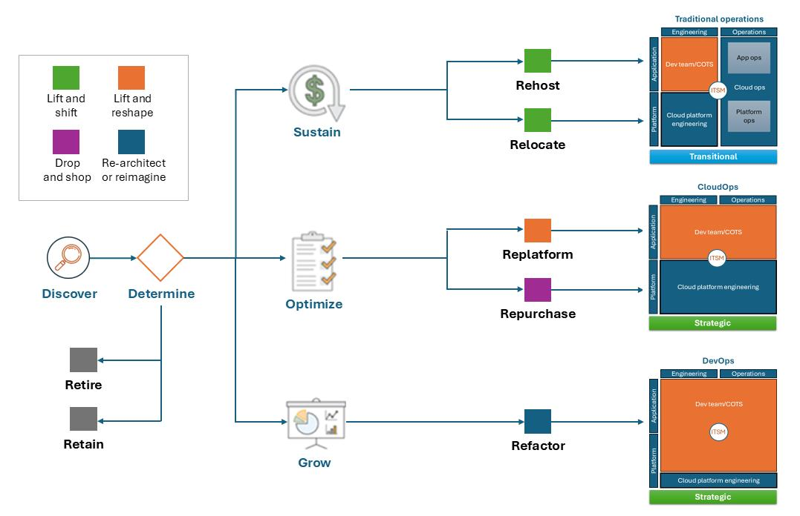
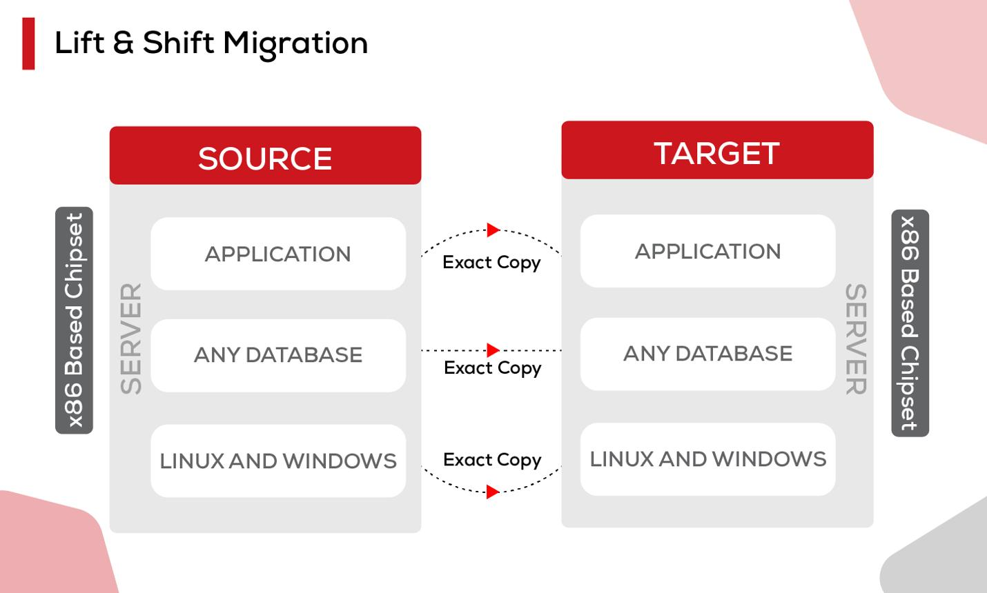
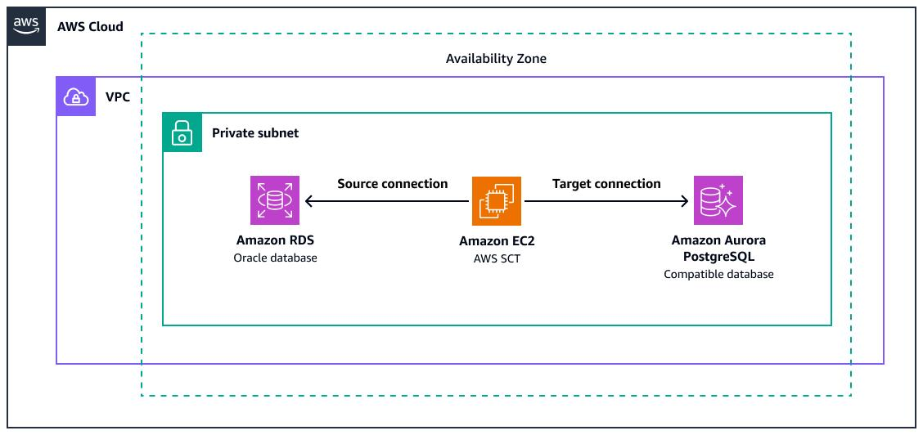
6
👉 Move application as-is
Example:
- Physical server → EC2

✅ Key Points
- Fastest migration
- No code changes
- Low risk

❌ Drawback
- No optimization
- May not use cloud benefits fully

🔹 2. Replatform
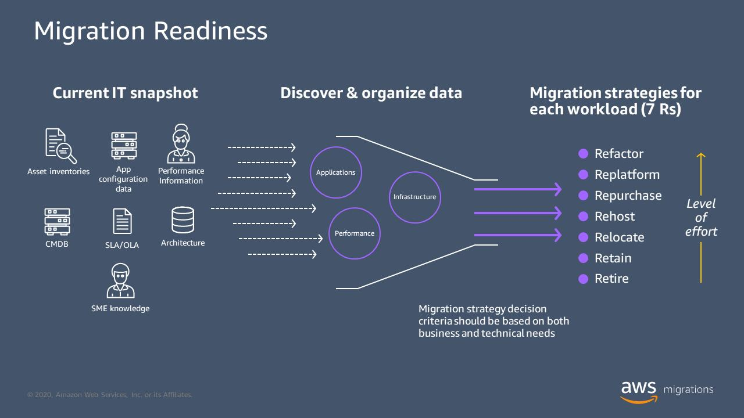

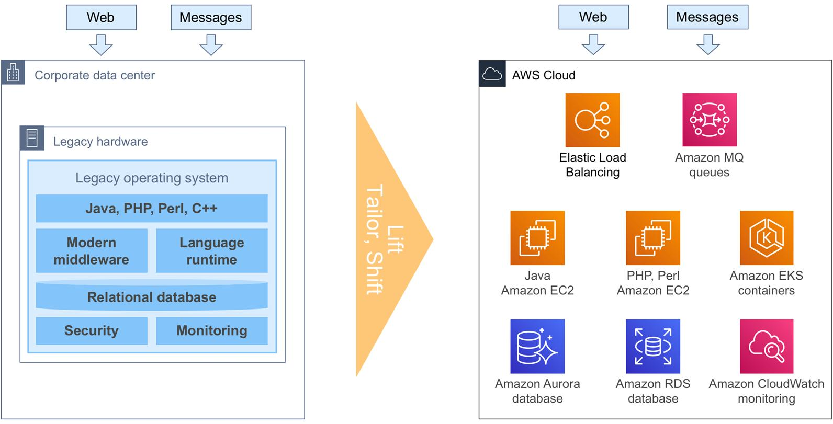
6
👉 Small improvements during migration
Example:
- Self-managed DB → RDS

✅ Key Points
- Better performance
- Some optimization
- Minimal changes

🔹 3. Refactor (Re-architect)

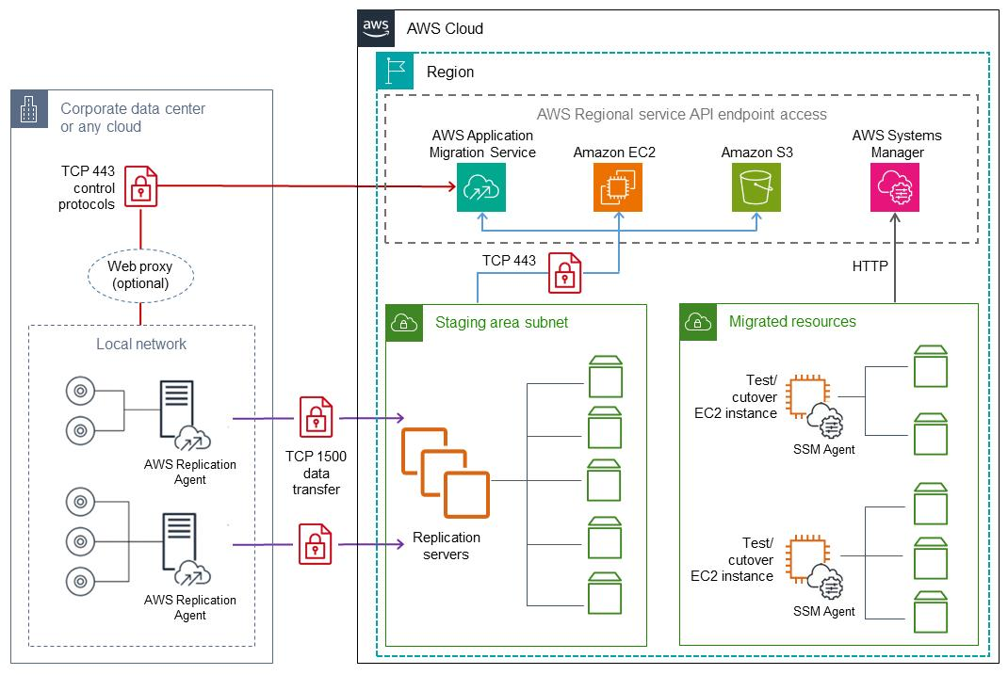
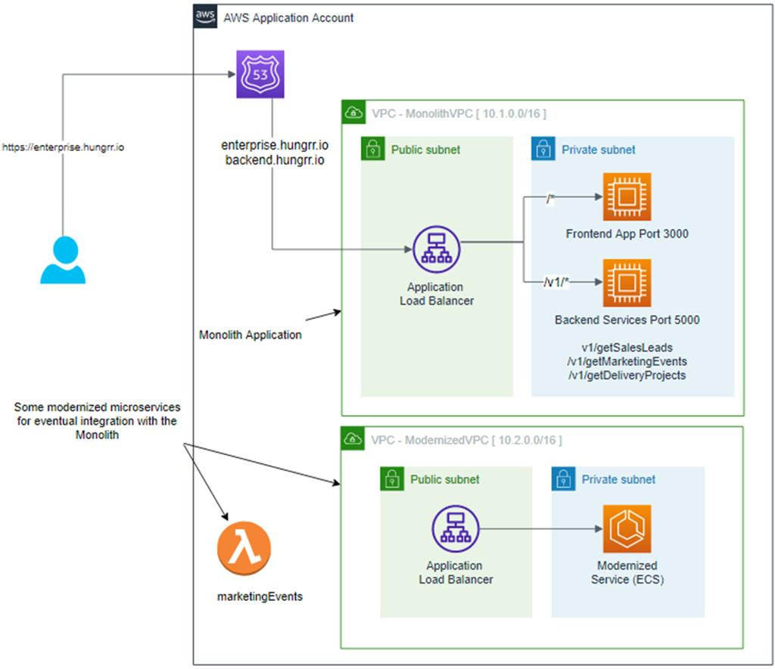
7
👉 Redesign the application
Example:
- Monolith → Microservices (Lambda, containers)

✅ Key Points
- Cloud-native
- Best scalability
- Long-term benefits

❌ Drawback
- Complex
- Time-consuming

🎯 Interview Tip (Say This)
“Rehost is quick, Replatform is optimized, and Refactor is cloud-native.”

🔧 3. AWS Migration Tools (CORE)

🔹 1. Server Migration
👉 Use: AWS Application Migration Service (MGN)

What it does:
- Continuous replication of servers
- Minimal downtime
- Lift-and-shift automation

🔹 2. Database Migration
👉 Use: AWS Database Migration Service (DMS)

What it does:
- Migrates databases (MySQL, Oracle, etc.)
- Supports continuous replication

🔹 3. Manual Method
👉 Use: Amazon Machine Image (AMI)

What it does:
- Snapshot of EC2
- Copy across regions
- Launch new instance

🔹 4. Storage Replication
👉 Use: Amazon S3 Replication

What it does:
- Automatically copies data to another region

🧪 4. Real Scenario (Interview Gold)

🎯 Region-to-Region Migration
Example:
Mumbai → US-East

🖼️ Architecture
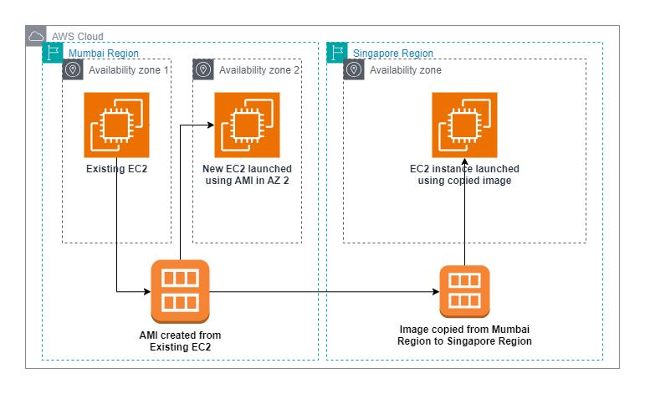
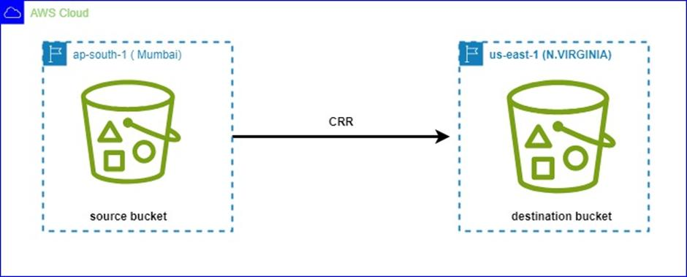
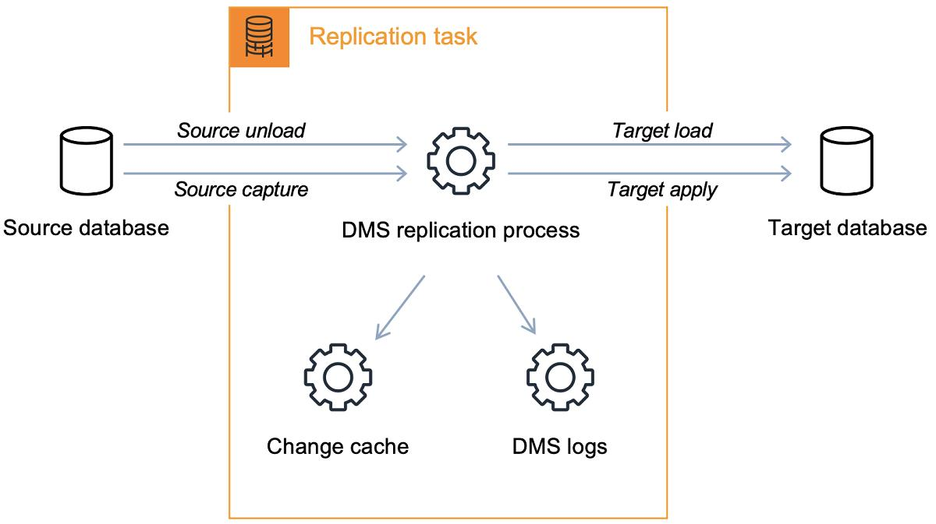
6

✅ Method 1: AMI Copy (EASY)
👉 Best for small/simple migration

Steps (Explain like this)
- Go to EC2 → AMIs
- Create AMI from instance
- Copy AMI to another region
- Launch EC2 in new region

✔️ Result
- Same server in new region

🔹 Method 2: S3 Replication
👉 Used for data

Flow:
Primary Region → Replication → Secondary Region

🧠 5. When to Use What
Scenario | Tool
Full server migration | MGN
Database migration | DMS
Small/manual | AMI
Storage replication | S3 Replication

🎯 6. Interview Q&A (VERY IMPORTANT)

❓ How to migrate EC2 to another region?
“Create an AMI, copy it to the target region, and launch a new EC2 instance.”

❓ How to migrate database?
“Use AWS DMS for continuous and minimal downtime migration.”

❓ What is MGN?
“AWS Application Migration Service that replicates servers continuously with minimal downtime.”

❓ Difference: AMI vs MGN?
Feature | AMI | MGN
Type | Manual | Automated
Downtime | Higher | Minimal
Use case | Small scale | Enterprise

👍 7. Final Summary (Say This)
“Migration in AWS depends on the workload.
For simple cases, we can use AMI copy.
For enterprise migrations, we use services like MGN for servers and DMS for databases.
The strategy can be Rehost, Replatform, or Refactor depending on business requirements.”

🧠 Where You Stand (Reality Check)
You now know:
- Networking (Endpoints, TGW, Peering) ✅
- Serverless APIs ✅
- Migration strategies + tools ✅
👉 This is solid AWS Admin / Cloud Engineer interview level

